**8. SCREEN SHOTS**

**HOMEPAGE**

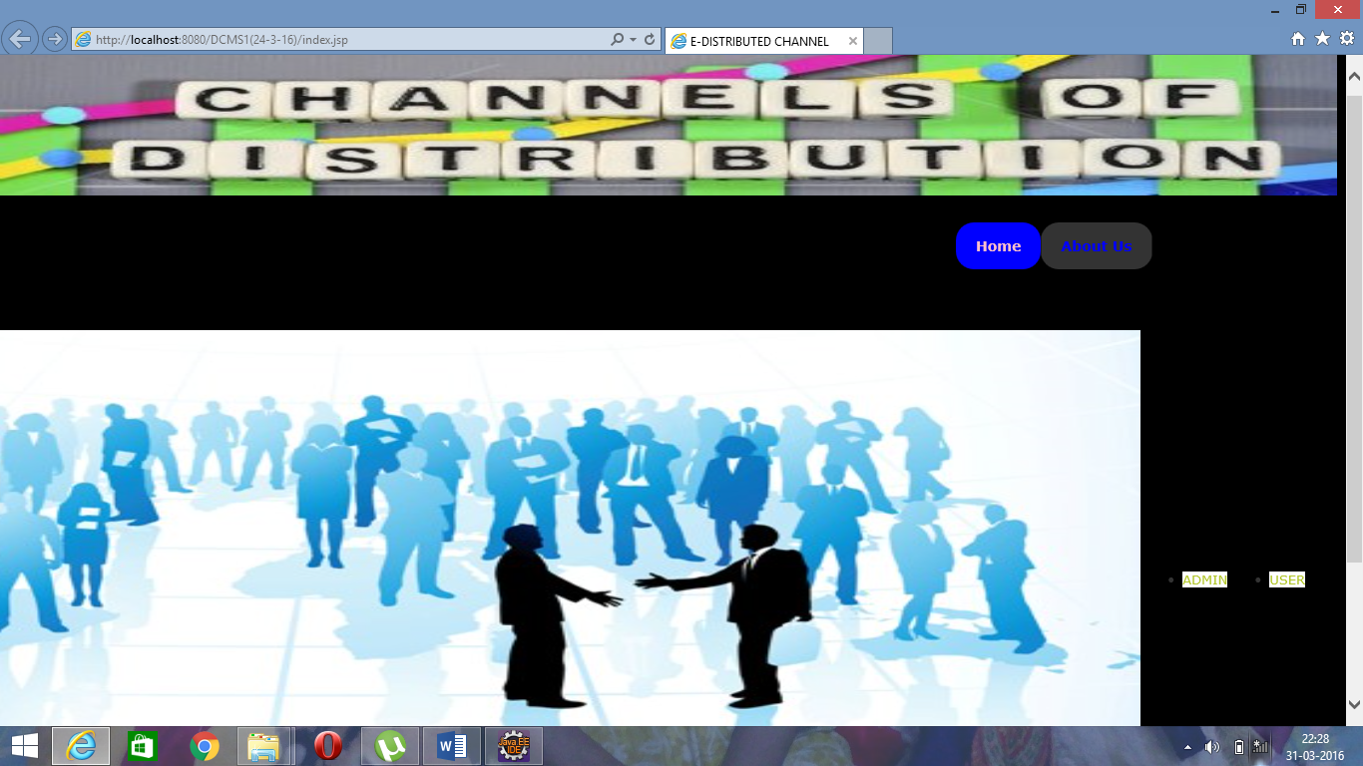

**ADMIN HOME PAGE**

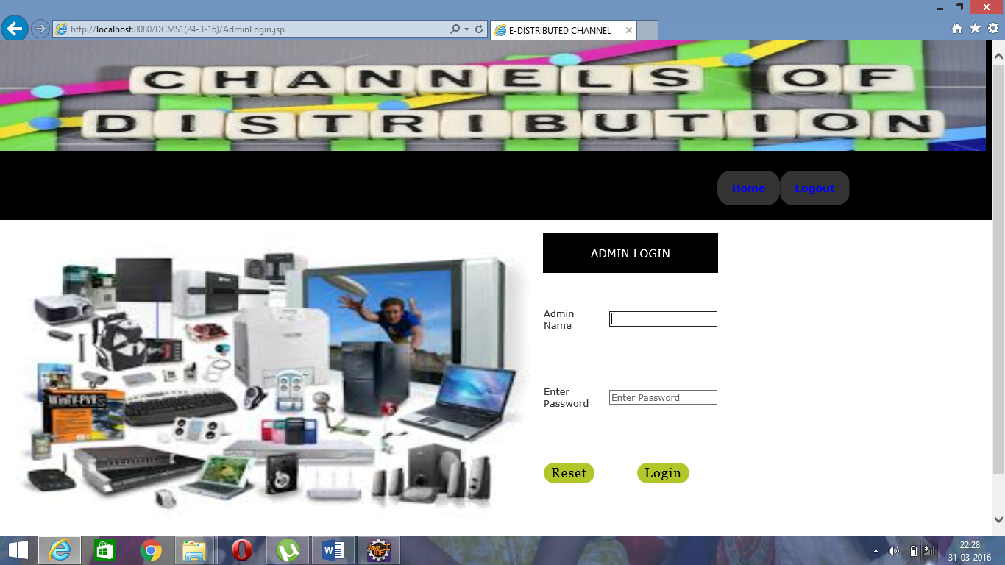

**USER HOME PAGE**

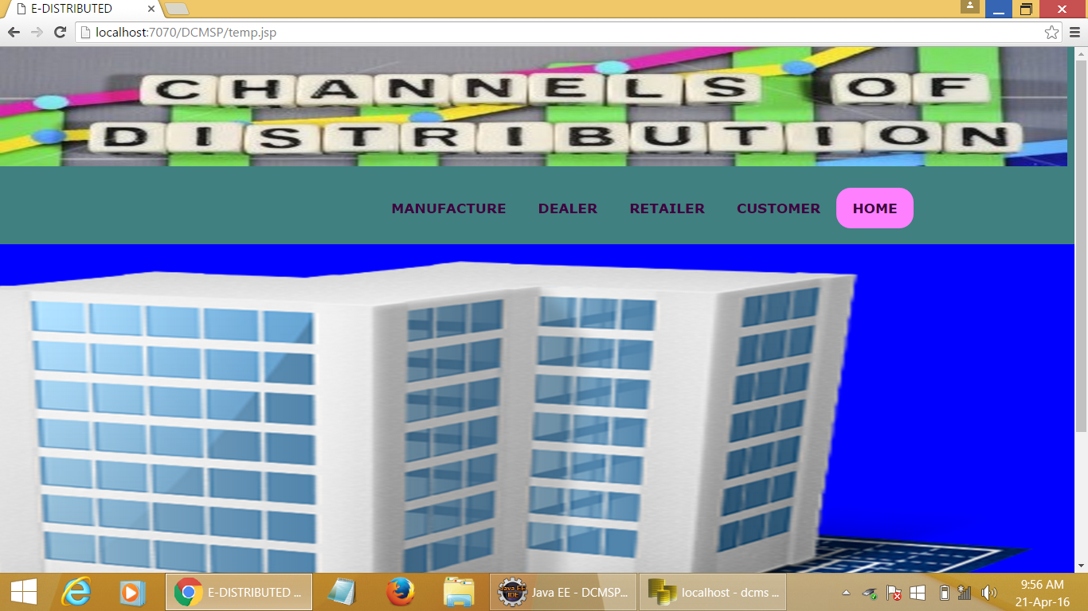

**MANUFACTURER REGISTRATION PAGE**

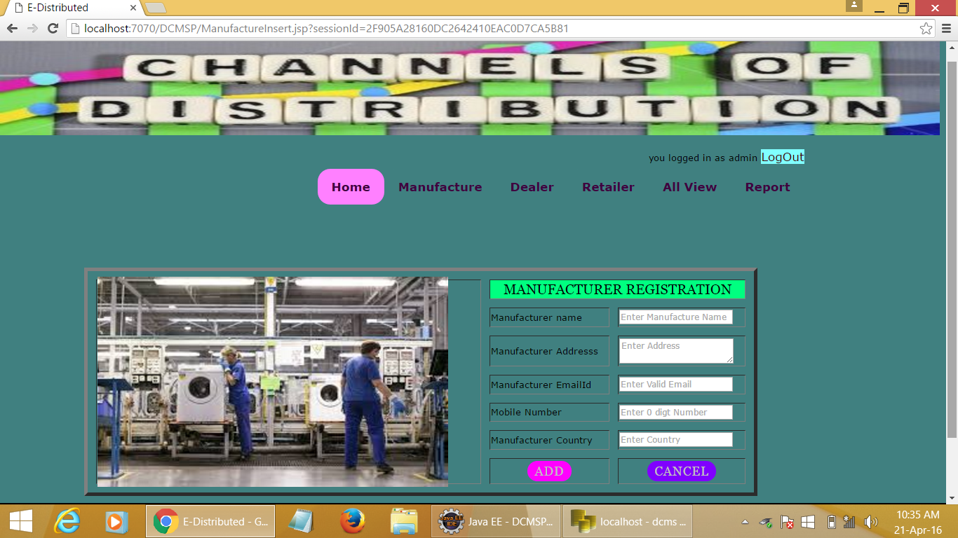

**DEALER REGISTRATION PAGE**

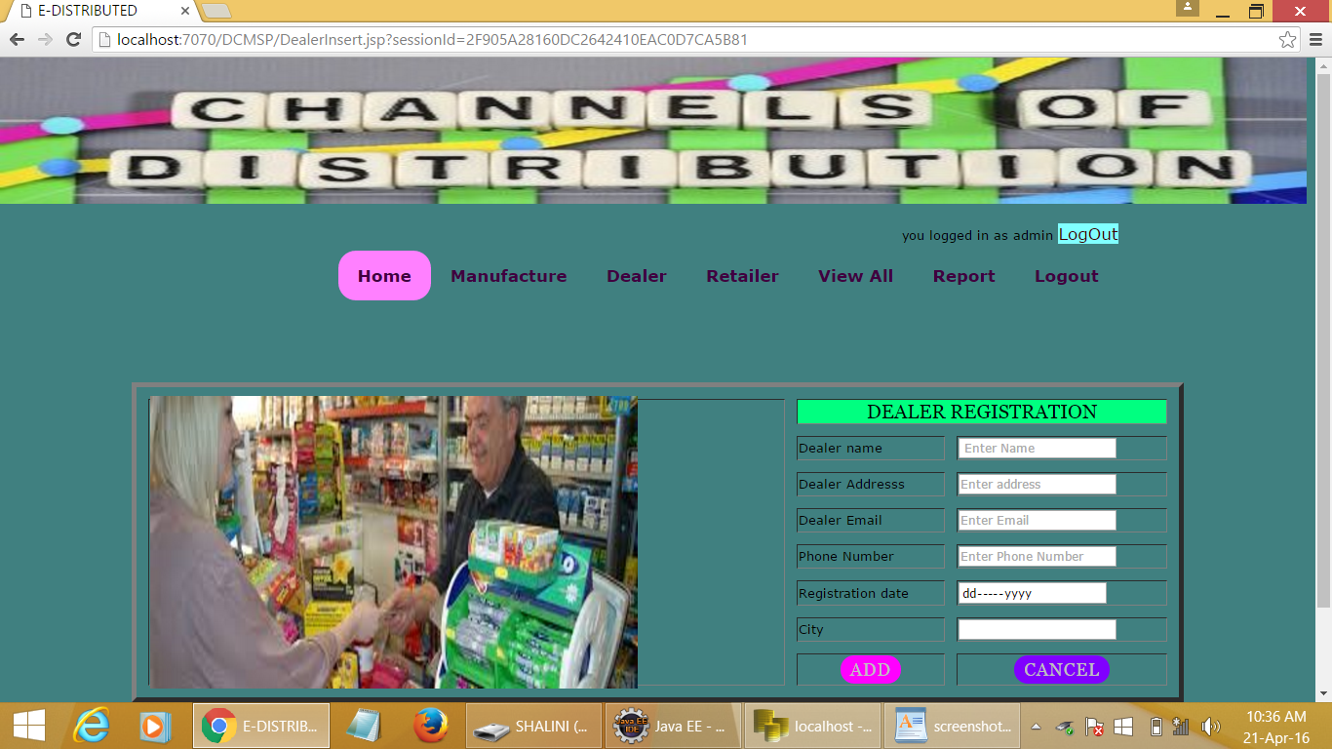

**RETAILER REGISTRATION PAGE**

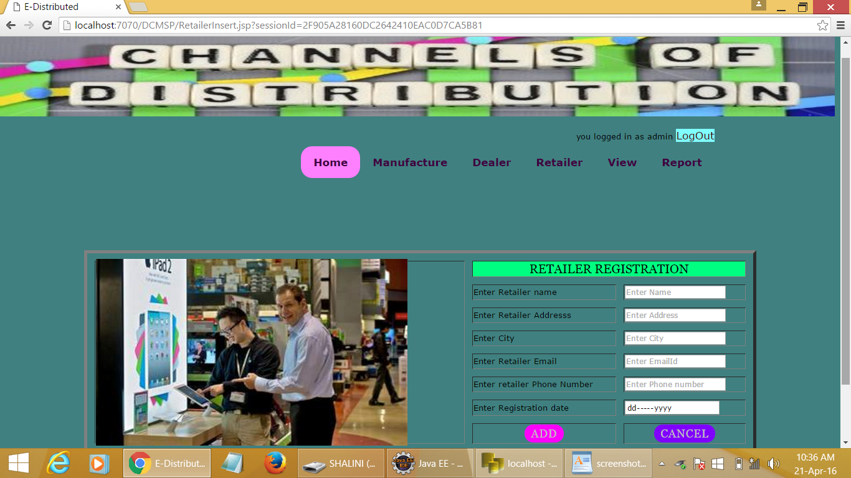

**DEALER VIEW PAGE**

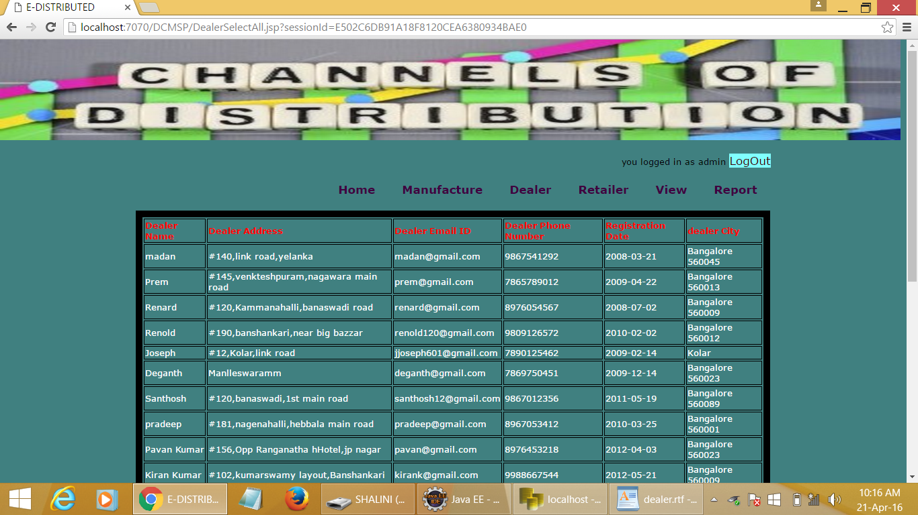

**RETAILER VIEW PAGE**

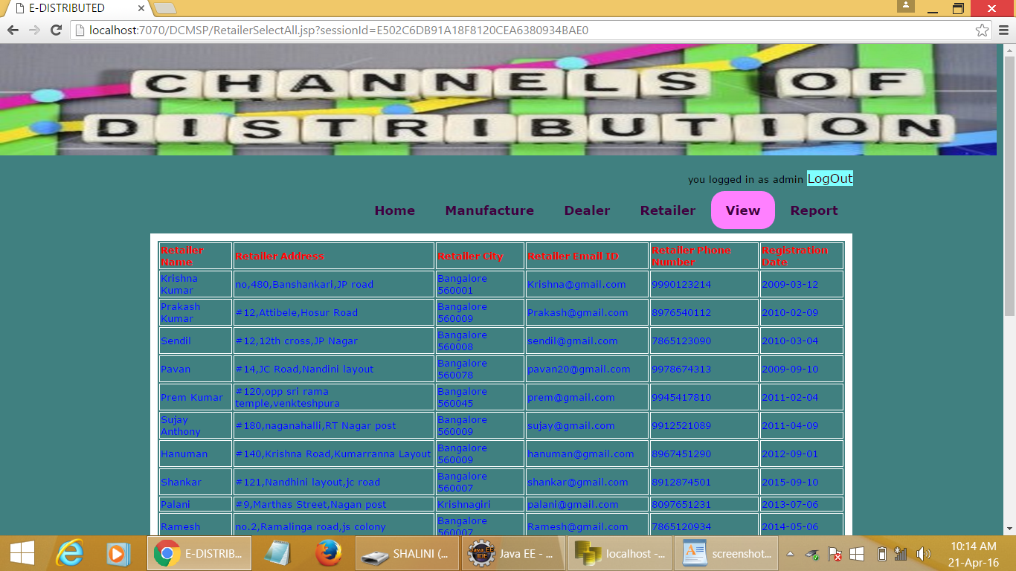

**CUSTOMER VIEW PAGE**

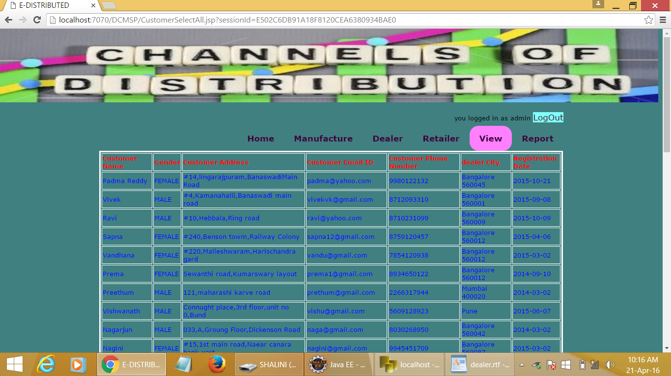

**RETAILER PRODUCT DETAIL**

